GRPC: gRPC is a modern open-source high performance Remote Procedure Call (RPC) framework that can run in any environment.

Grpc details: For completion of given task, I have chosen the python as a programming language and followed the below steps:

* Create python environment by: **python3 -m venv** myenv (name user preference)
* **Source /bin/activate** -> command for activate virtual environment
* **Need to install grpc package into machine as per requirement. (Strongly recommend that to follow the official document)**
* For more information follow the grpc official page: **https://grpc.io/docs/languages/python/quickstart/**
* verify by command: **pip list (**show the list of packages inside the virtual environment**)**
* **need to install grpc tools from command prompt**
* **python -m grpc_tools.protoc -I. --python_out=. --grpc_python_out=. Hello.proto** (generate the grpc files for services which contain the all information of. proto method)
* **Task_pb2.py, Task_pb2_grpc.py}:**
* **Tree -T (check the list of files)**

**Create server file using python:**

Import the inheritance method from different _pb2.py and pb2_grpc.py proto generated file folder into server which contain the proto file method including Listening port for accept the request and return back to the requester like client.

**Client file using python:**

This python file send the request and provoke the method inside the server trying to mapping the port number with client once verified that, then response the message.

Docker side: Dockerfile

This is the docker file which pull the images from docker hub and make container with Ubuntu OS for deployment.

Build Image command: **Docker build .**

FROM ubuntu:16.04

WORKDIR /root

ADD . /Task

RUN apt-get update

RUN apt-get install python3 python3-pip -y

RUN apt-get pip install -r /requirements.txt

ENTRYPOINT ["python", "greeter_server.py"]

**Compose file:** To bind our local files to our container files and execute the program. all the program are configure into .yaml file.

This is the command : **docker compose up**

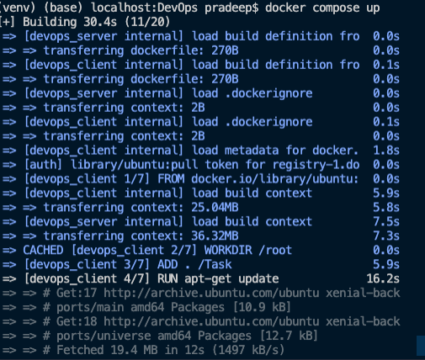

**Problem:**

**The challenges which I have faced during the implementation is keep the track records of configured version into .Txt files. For that I must focused on some more advance research materials.**

**GitHub command :**

git remote add origin https://github.com/pradeeppariyar/grpc.git

git branch -M main

git push -u origin main